MONDAY  11-5-2018 | TUESDAY  11-6-2018 | WEDNESDAY  11-7-2018 | THURSDAY  11-8-2018 | FRIDAY  11-9-2018
BREAKFAST  CHOCOLATE CRESENT | BREAKAST  BREAKFAST PIZZA | BREAKFAST  CINNAMON ROLLS | BREAKFAST  HAM BISCUIT | BREAKFAST  SAUSAGE & GRITS
LUNCH  - RIB A CUE  - POPCORN CHICKEN | LUNCH  - NACHOS  - CHICKEN FAJITA | LUNCH  - SALISBURY STEAK  - BUFFALO CHICKEN SANDWICH | LUNCH  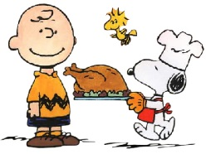  - OVEN ROASTED TURKEY  - HONEY GLAZED HAM | LUNCH  - PIZZA  - CHEESE BURGER

NORTH COLUMBUS ELEMENTARY

