MONDAY  1-7-2019 | TUESDAY  1-8-2019 | WEDNESDAY  1-9-2019 | THURSDAY  1-10-2019 | FRIDAY  1-11-2019
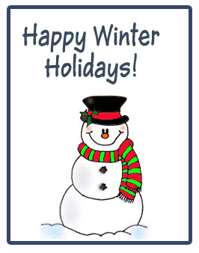 |  | WELCOME BACK  BREAKFAST  DONUT | WELCOME BACK  BREAKFAST  CHICKEN BISCUIT | WELCOME BACK  BREAKFAST  SAUSAGE AND GRITS
 |  | LUNCH  - SALISBURY STEAK  - BUFFALO CHICKEN SANDWICH | LUNCH  - POPCORN CHICKEN  - MINI CORN DOGS | LUNCH  - PIZZA  - CHICKEN FILET SANDWICH

NORTH COLUMBUS ELEMENTARY

