MONDAY  9-3-2018 | TUESDAY  9-4-2018 | WEDNESDAY  9-5-2018 | THURSDAY  9-6-2018 | FRIDAY  9-7-2018
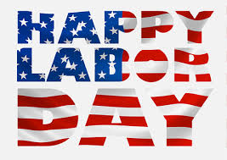 | BREAKAST  BREAKFAST PIZZA | BREAKFAST  CINNAMON ROLLS | BREAKFAST  VARIETY BISCUIT | BREAKFAST  GRITS & SAUSAGE
 | LUNCH  - BBQ SANDWICH  - HOT DOG | LUNCH  - SALISBURY STEAK W/ GRAVY  - BUFFALO CHICKEN SANDWICH | LUNCH  - BUFFALO CHICKEN BITES  - MINI CORN DOGS | LUNCH  - PIZZA  - CHICKEN SANDWICH
NORTH COLUMBUS ELEMENTARY

